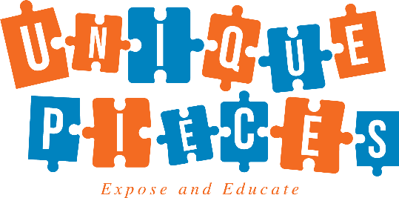
“Feeding the Body which Fuels the Soul & the Mind”
We all know kids can arrive Hungry and they leave Hungry! Truthful they are just always HUNGRY! That’s were Unique Pieces Inc. comes in.
We will provide your community with Free food all summer. Any youth ages 18 and under qualifies to receive a Free meal. We offer a freshly prepared Breakfast and Lunch. Our sites will also participate in our Hydrate One Million Campaign. We will serve water with each meal and donate FREE water to the organization.
When: June 2019 – August 2019
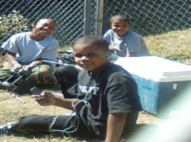
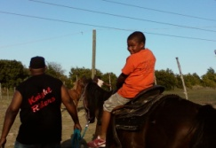
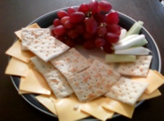
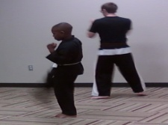
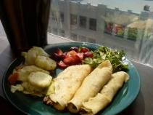

Do parents have to sign up the children?
No, any youth age 18 under may receive a Free meal.
What are some of the items on the menu?
Breakfast – Breakfast Tacos, Cereal, Sausage & Biscuit
Lunch – Turkey Corn Dogs, BBQ Chopped Beef & Turkey Wraps , Carrots, Green Beans & Fruit
How does the Hydrate One Million Campaign work?
By signing up for meal service you are automatically enrolled in the Hydrate One Million Campaign. Bottled water will be served with each meal. We will also donate cases of water to the organization.
How does this program benefit your organization?
- The program is Free of charge to your organization.
- Free Water for the Youth
- We will incur the cost of the food and preparation of the food.
- Balanced fresh meals will be delivered in a timely manner.

